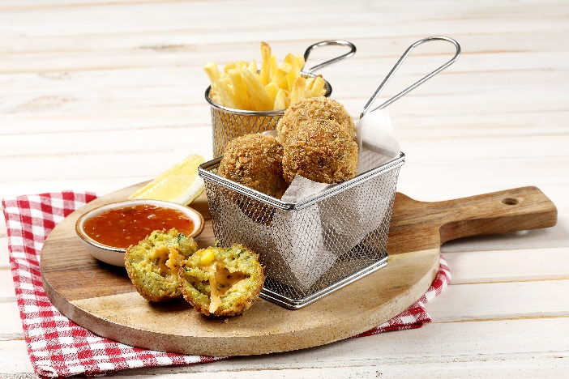

Cheesy Rice Balls
Makes: 18-20
Prep time: 20 minutes
Cooking time: 30 minutes

Ingredients:
750ml (3 cups) cooked Golden Delight Long Grain White Parboiled Thai Rice
2 slices white bread
2 extra large eggs
5ml (1 teaspoon) crushed garlic
2 green chillies, chopped
15ml (1 tablespoon) chopped coriander
15ml (1 tablespoon) chopped spring onions
250ml (1 cup) frozen corn kernels
60ml (4 tablespoons) flour
15ml (1 tablespoon) masala
Salt to taste
20 – 24 cubes of cheddar or feta
Panko crumbs
Oil for shallow frying

Method:
- Place the Golden Delight Rice, bread, eggs, garlic, chillies, herbs, corn, flour and masala and salt in a food processor and blend until 80% smooth.
- Transfer to a bowl, and with lightly floured hands, divide into 18 – 20 balls.
- Roll the balls, and then gently push a cube of cheese into the centre of each ball, rolling again to ensure it is completely covered.
- Roll the balls in panko crumbs to give it a light coating and place in the fridge.
- Heat the oil in a frying pan (1/2 full of oil) and fry the balls, turning carefully until golden all round.
- Serve with sweet chilli sauce or a tomato relish.

Tips:
- As an alternative, add in ½ a cup of cooked chopped chicken, tuna or mince and blend with the rice mixture for a meaty cheesy rice ball.
- These rice balls with its pops of carbohydrates, fibre and added protein from the cheese and eggs would work well in a side salad or wrap for a light meal.
- Choose wholewheat bread to increase fibre content, and feta or mozzarella cheese for a lower fat profile. Air fry instead of pan frying to reduce fat content.

